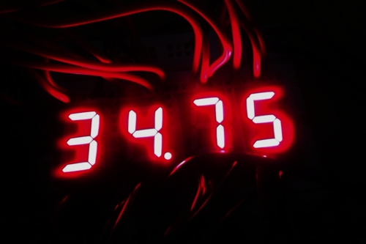

**Components used:**

IC 4511 x4  
Common Cathode 7-segment LED x4  
10k Resister x4  
10k Thermister x1  
Pickup wires  
Breadboard  
Arduino UNO

**Hardware diagram:**

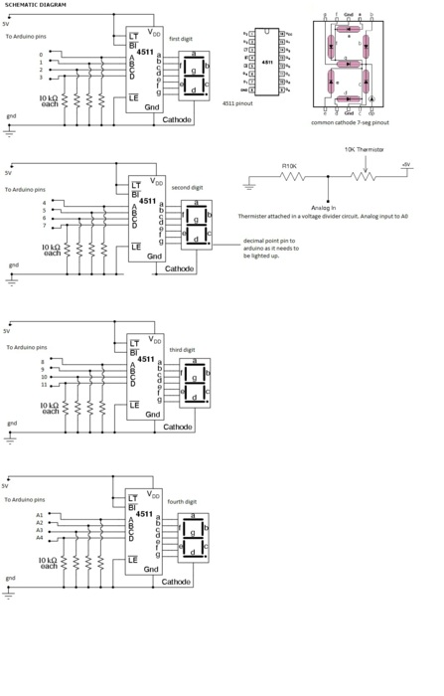

Well, the pic’s quite self explanatory, I guess.

**Code:**

*/\**

*Digital Thermometer with 7-segment display*

*Takes input from thermister, manipulates to find temperature and displays first four significant figures on 4 different 7-segment LEDs*

*Created by Aditya Kamath*

*\*/*

*#include<math.h> //includes header file for mathematical operations*

*int a1=0;*

*int a2=1;*

*int a3=2;*

*int a4=3; //4511 pins for 1st 7-seg LED*

*int b1=4;*

*int b2=5;*

*int b3=6;*

*int b4=7; //4511 pins for 2nd 7-seg LED*

*int c1=8;*

*int c2=9;*

*int c3=10;*

*int c4=11; //4511 pins for 3rd 7-seg LED*

*int d1=A1;*

*int d2=A2;*

*int d3=A3;*

*int d4=A4; //4511 pins for 4th 7-seg LED. shortage of pins, hence analog pins used*

*double Temp; //variable for temperature*

*//int dp=13; //initiallizes pin for decimal point*

*void setup()*

*{*

*pinMode(a1, OUTPUT);*

*pinMode(a2, OUTPUT);*

*pinMode(a3, OUTPUT);*

*pinMode(a4, OUTPUT); //pins for 1st 4511 IC*

*pinMode(b1, OUTPUT);*

*pinMode(b2, OUTPUT);*

*pinMode(b3, OUTPUT);*

*pinMode(b4, OUTPUT); //pins for 2nd 4511 IC*

*pinMode(c1, OUTPUT);*

*pinMode(c2, OUTPUT);*

*pinMode(c3, OUTPUT);*

*pinMode(c4, OUTPUT); //pins for 3rd 4511 IC*

*pinMode(d1, OUTPUT);*

*pinMode(d2, OUTPUT);*

*pinMode(d3, OUTPUT);*

*pinMode(d4, OUTPUT); //pins for 4th 4511 IC*

*pinMode(A0, INPUT); //thermister*

*Serial.begin(9600); //used for testing, to see serial output from thermister*

*}*

*void seg_a(int k)*

*{ //BCD output from Arduino Uno board to 4511 controlling first 7-segment for value received.*

*switch (k)*

*{ //checks value and sends BCD code for every value of variable*

*case 0:*

*digitalWrite(a1, 0);*

*digitalWrite(a2, 0);*

*digitalWrite(a3, 0);*

*digitalWrite(a4, 0);*

*break;*

*case 1:*

*digitalWrite(a1, 1);*

*digitalWrite(a2, 0);*

*digitalWrite(a3, 0);*

*digitalWrite(a4, 0);*

*break;*

*case 2:*

*digitalWrite(a1, 0);*

*digitalWrite(a2, 1);*

*digitalWrite(a3, 0);*

*digitalWrite(a4, 0);*

*break;*

*case 3:*

*digitalWrite(a1, 1);*

*digitalWrite(a2, 1);*

*digitalWrite(a3, 0);*

*digitalWrite(a4, 0);*

*break;*

*case 4:*

*digitalWrite(a1, 0);*

*digitalWrite(a2, 0);*

*digitalWrite(a3, 1);*

*digitalWrite(a4, 0);*

*break;*

*case 5:*

*digitalWrite(a1, 1);*

*digitalWrite(a2, 0);*

*digitalWrite(a3, 1);*

*digitalWrite(a4, 0);*

*break;*

*case 6:*

*digitalWrite(a1, 0);*

*digitalWrite(a2, 1);*

*digitalWrite(a3, 1);*

*digitalWrite(a4, 0);*

*break;*

*case 7:*

*digitalWrite(a1, 1);*

*digitalWrite(a2, 1);*

*digitalWrite(a3, 1);*

*digitalWrite(a4, 0);*

*break;*

*case 8:*

*digitalWrite(a1, 0);*

*digitalWrite(a2, 0);*

*digitalWrite(a3, 0);*

*digitalWrite(a4, 1);*

*break;*

*case 9:*

*digitalWrite(a1, 1);*

*digitalWrite(a2, 0);*

*digitalWrite(a3, 0);*

*digitalWrite(a4, 1);*

*break;*

*}*

*}*

*void seg_b(int l)*

*{ //BCD output from Arduino Uno board to 4511 controlling second 7-segment for value received.*

*switch (l)*

*{ //checks value and sends BCD code for every value of variable*

*case 0:*

*digitalWrite(b1, 0);*

*digitalWrite(b2, 0);*

*digitalWrite(b3, 0);*

*digitalWrite(b4, 0);*

*break;*

*case 1:*

*digitalWrite(b1, 1);*

*digitalWrite(b2, 0);*

*digitalWrite(b3, 0);*

*digitalWrite(b4, 0);*

*break;*

*case 2:*

*digitalWrite(b1, 0);*

*digitalWrite(b2, 1);*

*digitalWrite(b3, 0);*

*digitalWrite(b4, 0);*

*break;*

*case 3:*

*digitalWrite(b1, 1);*

*digitalWrite(b2, 1);*

*digitalWrite(b3, 0);*

*digitalWrite(b4, 0);*

*break;*

*case 4:*

*digitalWrite(b1, 0);*

*digitalWrite(b2, 0);*

*digitalWrite(b3, 1);*

*digitalWrite(b4, 0);*

*break;*

*case 5:*

*digitalWrite(b1, 1);*

*digitalWrite(b2, 0);*

*digitalWrite(b3, 1);*

*digitalWrite(b4, 0);*

*break;*

*case 6:*

*digitalWrite(b1, 0);*

*digitalWrite(b2, 1);*

*digitalWrite(b3, 1);*

*digitalWrite(b4, 0);*

*break;*

*case 7:*

*digitalWrite(b1, 1);*

*digitalWrite(b2, 1);*

*digitalWrite(b3, 1);*

*digitalWrite(b4, 0);*

*break;*

*case 8:*

*digitalWrite(b1, 0);*

*digitalWrite(b2, 0);*

*digitalWrite(b3, 0);*

*digitalWrite(b4, 1);*

*break;*

*case 9:*

*digitalWrite(b1, 1);*

*digitalWrite(b2, 0);*

*digitalWrite(b3, 0);*

*digitalWrite(b4, 1);*

*break;*

*}*

*}*

*void seg_c(int m)*

*{ //BCD output from Arduino Uno board to 4511 controlling third 7-segment for value received.*

*switch (m)*

*{ //checks value and sends BCD code for every value of variable*

*case 0:*

*digitalWrite(c1, 0);*

*digitalWrite(c2, 0);*

*digitalWrite(c3, 0);*

*digitalWrite(c4, 0);*

*break;*

*case 1:*

*digitalWrite(c1, 1);*

*digitalWrite(c2, 0);*

*digitalWrite(c3, 0);*

*digitalWrite(c4, 0);*

*break;*

*case 2:*

*digitalWrite(c1, 0);*

*digitalWrite(c2, 1);*

*digitalWrite(c3, 0);*

*digitalWrite(c4, 0);*

*break;*

*case 3:*

*digitalWrite(c1, 1);*

*digitalWrite(c2, 1);*

*digitalWrite(c3, 0);*

*digitalWrite(c4, 0);*

*break;*

*case 4:*

*digitalWrite(c1, 0);*

*digitalWrite(c2, 0);*

*digitalWrite(c3, 1);*

*digitalWrite(c4, 0);*

*break;*

*case 5:*

*digitalWrite(c1, 1);*

*digitalWrite(c2, 0);*

*digitalWrite(c3, 1);*

*digitalWrite(c4, 0);*

*break;*

*case 6:*

*digitalWrite(c1, 0);*

*digitalWrite(c2, 1);*

*digitalWrite(c3, 1);*

*digitalWrite(c4, 0);*

*break;*

*case 7:*

*digitalWrite(c1, 1);*

*digitalWrite(c2, 1);*

*digitalWrite(c3, 1);*

*digitalWrite(c4, 0);*

*break;*

*case 8:*

*digitalWrite(c1, 0);*

*digitalWrite(c2, 0);*

*digitalWrite(c3, 0);*

*digitalWrite(c4, 1);*

*break;*

*case 9:*

*digitalWrite(c1, 1);*

*digitalWrite(c2, 0);*

*digitalWrite(c3, 0);*

*digitalWrite(c4, 1);*

*break;*

*}*

*}*

*void seg_d(int n)*

*{ //BCD output from Arduino Uno board to 4511 controlling fourth 7-segment for value received.*

*switch (n)*

*{ //checks value and sends BCD code for every value of variable*

*case 0:*

*digitalWrite(d1, 0);*

*digitalWrite(d2, 0);*

*digitalWrite(d3, 0);*

*digitalWrite(d4, 0);*

*break;*

*case 1:*

*digitalWrite(d1, 1);*

*digitalWrite(d2, 0);*

*digitalWrite(d3, 0);*

*digitalWrite(d4, 0);*

*break;*

*case 2:*

*digitalWrite(d1, 0);*

*digitalWrite(d2, 1);*

*digitalWrite(d3, 0);*

*digitalWrite(d4, 0);*

*break;*

*case 3:*

*digitalWrite(d1, 1);*

*digitalWrite(d2, 1);*

*digitalWrite(d3, 0);*

*digitalWrite(d4, 0);*

*break;*

*case 4:*

*digitalWrite(d1, 0);*

*digitalWrite(d2, 0);*

*digitalWrite(d3, 1);*

*digitalWrite(d4, 0);*

*break;*

*case 5:*

*digitalWrite(d1, 1);*

*digitalWrite(d2, 0);*

*digitalWrite(d3, 1);*

*digitalWrite(d4, 0);*

*break;*

*case 6:*

*digitalWrite(d1, 0);*

*digitalWrite(d2, 1);*

*digitalWrite(d3, 1);*

*digitalWrite(d4, 0);*

*break;*

*case 7:*

*digitalWrite(d1, 1);*

*digitalWrite(d2, 1);*

*digitalWrite(d3, 1);*

*digitalWrite(d4, 0);*

*break;*

*case 8:*

*digitalWrite(d1, 0);*

*digitalWrite(d2, 0);*

*digitalWrite(d3, 0);*

*digitalWrite(d4, 1);*

*break;*

*case 9:*

*digitalWrite(d1, 1);*

*digitalWrite(d2, 0);*

*digitalWrite(d3, 0);*

*digitalWrite(d4, 1);*

*break;*

*}*

*}*

*void led_disp(int a, int b, int c, int d)*

*{ //function takes input value from loop function and sends values to BCD output functions mentioned above.*

*seg_a(a); //a,b,c,d are the four digits of the temperature*

*seg_b(b);*

*seg_c(c);*

*seg_d(d);*

*}*

*double therm(int input)*

*{ //reads input, calculates temperature in celcius and then returns value*

*Temp = log(((10240000/input) - 10000));*

*Temp = 1 / (0.001129148 + (0.000234125 * Temp) + (0.0000000876741 * Temp * Temp * Temp)); //formula to convert analog value to temperature*

*Temp = Temp - 273.15;//converts celvin to celcius*

*Temp= -Temp; //connection: ground—>thermister—>resister—>Vcc and Analog input wire from node between thermister and resister to A0*

*Temp= Temp*100; //makes 4 digit integer where each digit is separated in void loop()*

*return Temp;*

*}*

*void loop()*

*{*

*digitalWrite(13, HIGH); //lights up decimal point*

*therm(analogRead(A0));*

*Serial.println(Temp); //for testing analog input from thermister*

*delay(1000); //for testing*

*int t=Temp; //was causing problems if ‘Temp’ was used directly as statement with double & int not allowed*

*int u=t%10; //extracts units place term*

*t=t/10; //removes units place term*

*int v=t%10; //extracts units place term from the remaining part of t*

*t=t/10; //removes units place term*

*int w=t%10; //extracts units place term from remaining part of t*

*t=t/10; //removes units place term*

*int x=t%10; //extracts term - first term of the original t*

*Serial.print(x);*

*Serial.print(w);*

*Serial.print(v);*

*Serial.println(u); //for testing output*

*led_disp(x,w,v,u); //calls aforementioned function. provides numbers to be displayed on each 7-segment*

*}*

**Final output:**

